**EXPERIMENT-5**

**Student Name:** Siddharth Rastogi **UID:**22BET10095

**Branch:** BE -IT **Section/Group:**22BET_IOT-703(B)

**Semester:** 6th **Subject Code:** 22ITP-351

# PROBLEM-1

## AIM:-

[Longest Increasing Subsequence](https://leetcode.com/problems/longest-nice-substring/)

## CODE:-

class Solution {

public int lengthOfLIS(int[] nums) { List<Integer> res = new ArrayList<>();

for (int n : nums) {

if (res.isEmpty() || res.get(res.size() - 1) < n) { res.add(n);

} else {

int idx = binarySearch(res, n); res.set(idx, n);

}

}

return res.size();

}

private int binarySearch(List<Integer> arr, int target) { int left = 0;

int right = arr.size() - 1;

while (left <= right) {

int mid = (left + right) / 2; if (arr.get(mid) == target) {

return mid;

} else if (arr.get(mid) > target) { right = mid - 1;

} else {

left = mid + 1;

}

}

return left;

}

}

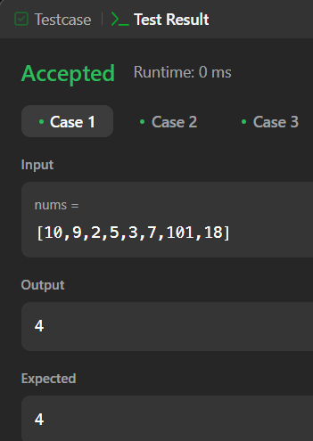**OUTPUT:-**

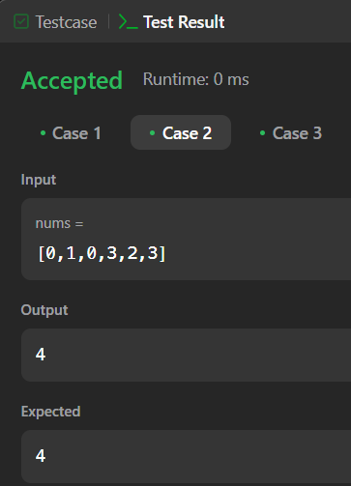

# PROBLEM-2

## AIM:-

Maximum Product Subarray

## CODE:-

class Solution {

public int maxProduct(int[] nums) { int res = Integer.MIN_VALUE; for (int n : nums) {

res = Math.max(res, n);

}

int curMax = 1, curMin = 1;

for (int n : nums) {

int temp = curMax * n;

curMax = Math.max(temp, Math.max(curMin * n, n));

curMin = Math.min(temp, Math.min(curMin * n, n));

res = Math.max(res, curMax);

}

return res;

}

}

**OUTPUT:-**

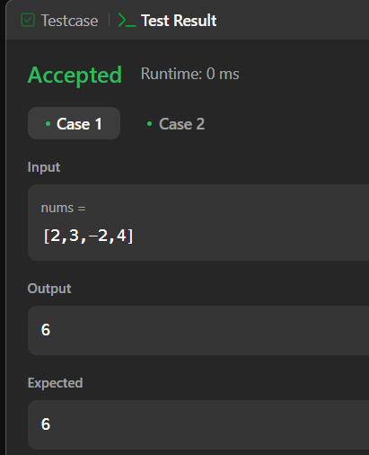

# PROBLEM-3

**AIM:-**

Decode Ways

**CODE:-**

class Solution {

public int numDecodings(String s) { if (s.charAt(0) == '0') {

return 0;

}

int n = s.length();

int[] dp = new int[n + 1]; dp[0] = dp[1] = 1;

for (int i = 2; i <= n; i++) {

int one = Character.getNumericValue(s.charAt(i - 1)); int two = Integer.parseInt(s.substring(i - 2, i));

if (1 <= one && one <= 9) { dp[i] += dp[i - 1];

}

if (10 <= two && two <= 26) { dp[i] += dp[i - 2];

}

}

return dp[n];

}

}

**OUTPUT:-**

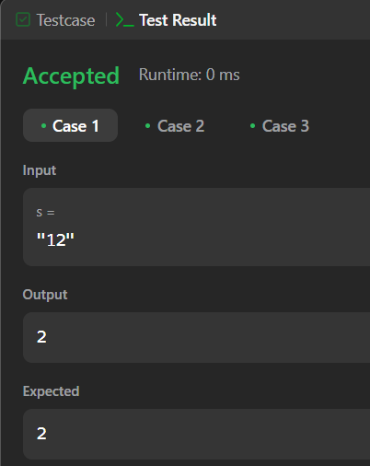

# PROBLEM-4

## AIM:-

Coin Change

## CODE:-

class Solution {

public int coinChange(int[] coins, int amount) { int[] minCoins = new int[amount + 1]; Arrays.fill(minCoins, amount + 1); minCoins[0] = 0;

for (int i = 1; i <= amount; i++) {

for (int j = 0; j < coins.length; j++) { if (i - coins[j] >= 0) {

minCoins[i] = Math.min(minCoins[i], 1 + minCoins[i - coins[j]]);

}

}

}

return minCoins[amount] != amount + 1 ? minCoins[amount] : -1;

}

} **OUTPUT:-**

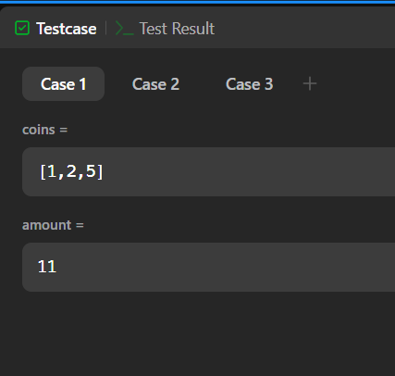

# PROBLEM-5

## AIM:-

Perfect Squares

## CODE:-

public class Solution {

public boolean searchMatrix(int[][] matrix, int target) { if(matrix == null || matrix.length < 1 || matrix[0].length <1) {

return false;

}

int col = matrix[0].length-1; int row = 0;

while(col >= 0 && row <= matrix.length-1) { if(target == matrix[row][col]) {

return true;

} else if(target < matrix[row][col]) { col--;

} else if(target > matrix[row][col]) { row++;

}

}

return false;

}

}

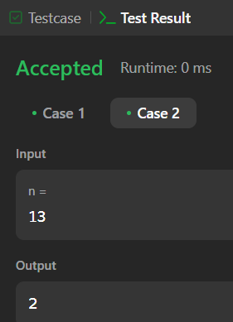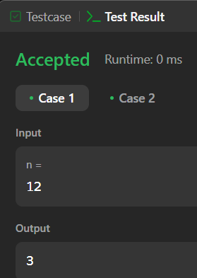

# PROBLEM-6

## AIM:-

Word Break **CODE:- OUTPUT:-**

class Solution {

public boolean wordBreak(String s, List<String> wordDict) { return recWay1(s, wordDict);

}

boolean recWay2(String s, List<String> wordDict) { Boolean[] memo = new Boolean[s.length() + 1];

return wordBreak2(s, new HashSet<>(wordDict), 0, memo);

}

boolean wordBreak2(String s, Set<String> wordDict, int k, Boolean[] memo) { int n = s.length();

if (k == n) return true;

if (memo[k] != null) return memo[k];

for (int i=k + 1; i<=n; i++) { String word = s.substring(k, i);

if (wordDict.contains(word) && wordBreak2(s, wordDict, i, memo)) { return memo[k] = true;

}

}

return memo[k] = false;

}

boolean recWay1(String s, List<String> wordDict) { Boolean[] memo = new Boolean[s.length() + 1]; return wordBreak(s, wordDict, 0, memo);

}

boolean wordBreak(String s, List<String> wordDict, int k, Boolean[] memo) { if (k == s.length()) {

return true;

}

if (memo[k] != null) { return memo[k];

}

for (int i=0; i<wordDict.size(); i++) { String word = wordDict.get(i);

if (s.startsWith(word, k)) {

if(wordBreak(s, wordDict, k + word.length(), memo)) return memo[k] = true;

}

}

return memo[k] = false;

}

}

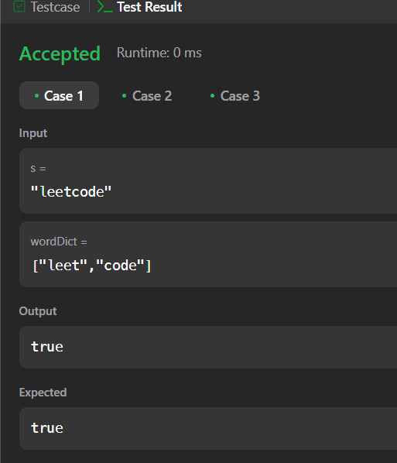

# PROBLEM-7

## AIM:-

Word Break 2

## CODE:-

import java.util.*;

class Solution {

public List<String> wordBreak(String s, List<String> wordDict) { Set<String> wordSet = new HashSet<>(wordDict); Map<Integer, List<String>> memo = new HashMap<>();

return backtrack(s, 0, wordSet, memo);

}

private List<String> backtrack(String s, int start, Set<String> wordSet, Map<Integer, List<String>> memo) {

if (memo.containsKey(start)) { return memo.get(start);

}

List<String> result = new ArrayList<>();

if (start == s.length()) { result.add("");

return result;

}

for (int end = start + 1; end <= s.length(); end++) { String word = s.substring(start, end);

if (wordSet.contains(word)) {

List<String> sublist = backtrack(s, end, wordSet, memo); for (String sub : sublist) {

if (sub.isEmpty()) { result.add(word);

} else {

result.add(word + " " + sub);

}

}

}

}

memo.put(start, result);

return result;

}

}

